**Name:.....................................................................stream:...............LIN:...................**

**STANDARD COLLEGE – BUGIRI**

**Uganda Certificate of Education.**

**Biology 553/1**

**Theory**

**Time: 2hours and 15 minutes**

**Instructions**

This paper consists of **TWO** sections **A** and **B**.

Section **A** comprisesof 3 compulsory items and section **B** comprises of **PART I** and **PART** **II** with a total of 4 items.

Attempt **ALL** the items in **section A** and only **TWO** item in **section B** picking one from each part.

**SECTION A**

**Structured items.**

**Item 1**

Plants as living organisms undertake various processes within their body systems to sustain their life. Cassava farmers in soroti district got affected by the invasion of locusts on thier crop plantations. These cassava crops benefit the farmers by ensuring food security in the area and also ensuring financial stability in households.

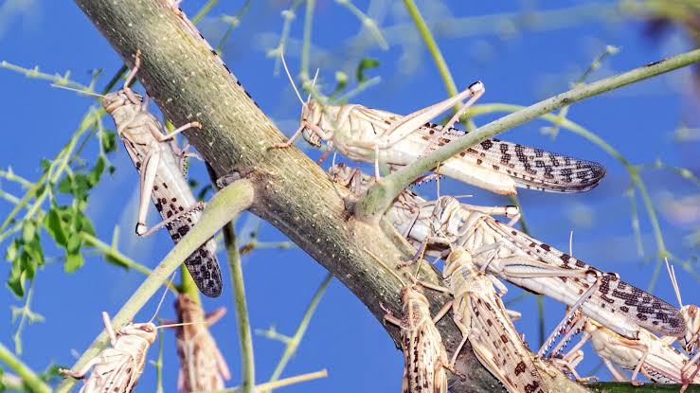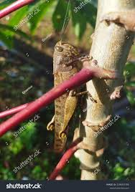The farmers are frustrated and now seek intervention from the government.

1. Suggest the organs of the cassava plants that affected the invasion of the locusts.

...............................................................................................................................................................................................................................................................................................................................................

...............................................................................................................................................................................................................................................................................................................................................

1. Explain what would happen to the cassava plant from the perspective of the organs affected

................................................................................................................................................................................................................................................................................................................................................

......................................................................................................................................................................................................................................................................................................................................................................................................................................................................................................................

................................................................................................................................................................................................................................................................................................................................................

......................................................................................................................................................................................................................................................................................................................................................................................................................................................................................................................

................................................................................................................................................................................................................................................................................................................................................

......................................................................................................................................................................................................................................................................................................................................................................................................................................................................................................................

................................................................................................................................................................................................................................................................................................................................................

......................................................................................................................................................................................................................................................................................................................................................................................................................................................................................................................

1. Suggest why it was a necessary for the government to intervene in the tragedy in soroti district.

................................................................................................................................................................................................................................................................................................................................................

......................................................................................................................................................................................................................................................................................................................................................................................................................................................................................................................

................................................................................................................................................................................................................................................................................................................................................

......................................................................................................................................................................................................................................................................................................................................................................................................................................................................................................................

**Item Two**

Olwamu a S.4 student at Standard College Bugiri while walking home from a prep lesson, he encountered a furious dog which barked at him with attempts to bit him.

He decided to bend down in disguise to pick some a stone. Then the dog ran away.

He then realized that him pulse rate was very high and he could breath so fast

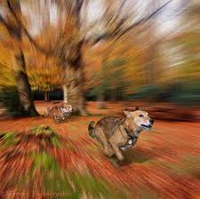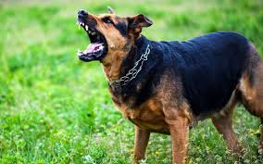

1. Describe the events that occurred in Olwamu's body to bring about his reactions.

................................................................................................................................................................................................................................................................................................................................................

................................................................................................................................................................................................................................................................................................................................................

................................................................................................................................................................................................................................................................................................................................................

................................................................................................................................................................................................................................................................................................................................................

................................................................................................................................................................................................................................................................................................................................................

................................................................................................................................................................................................................................................................................................................................................

................................................................................................................................................................................................................................................................................................................................................

................................................................................................................................................................................................................................................................................................................................................

1. Describe the events that occurred in dog's body to bring about the reactions.

................................................................................................................................................................................................................................................................................................................................................

................................................................................................................................................................................................................................................................................................................................................

................................................................................................................................................................................................................................................................................................................................................

................................................................................................................................................................................................................................................................................................................................................

................................................................................................................................................................................................................................................................................................................................................

................................................................................................................................................................................................................................................................................................................................................

**Item Three**

The couple both with dark skin pigmentation was happily married and after 2 years, they begot a pale skin pigmented daughter. The man accused the woman for having cheated on him with another man as the daughter’s skin would not match with either of the parents.

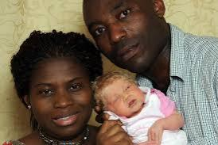The man plans to divorce the woman for alleged adultery

1. Identify the genetic disorder and show how it came about in the family.

................................................................................................................................................................................................................................................................................................................................................

................................................................................................................................................................................................................................................................................................................................................

................................................................................................................................................................................................................................................................................................................................................

................................................................................................................................................................................................................................................................................................................................................

................................................................................................................................................................................................................................................................................................................................................

................................................................................................................................................................................................................................................................................................................................................

................................................................................................................................................................................................................................................................................................................................................

................................................................................................................................................................................................................................................................................................................................................

1. Suggest how the family can manage their situation without hurting each other.

................................................................................................................................................................................................................................................................................................................................................

................................................................................................................................................................................................................................................................................................................................................

................................................................................................................................................................................................................................................................................................................................................

................................................................................................................................................................................................................................................................................................................................................

................................................................................................................................................................................................................................................................................................................................................

................................................................................................................................................................................................................................................................................................................................................

................................................................................................................................................................................................................................................................................................................................................

................................................................................................................................................................................................................................................................................................................................................

**SECTION B**

**PART I**

Attempt only one item from this part. Answers should be written from the answer booklet provided.

**Item Four**

In Bukatu community, the soils are muddy and when it rains, the soil is massive carried into the nearby swamp. Farmers crops are destroyed too.

Farmers have now resolved to carry out their farming activities in the swamp claiming that the soils there are more fertile and crops can not be washed away.

**Task**

As a learned person in the community, address the community on the possible outcomes of their decision and how best they cam managed their farming activities without interfering with the natural resources.

**Item Five**

Ochwo is a horticultural farmer who grows a number of fruit plants on which he depends for his entire livelihood.

In one village meeting for farmers he quoted from the District Agricultural officer’s speech that *“insects are vectors, they can spread diseases from one infected plant to a health plant"*

Ochwo have stocked all kinds of insecticides to use whenever he observes insects on his fruit plants.

**Task**

Guide Ochwo, explaining to him how the use of insecticides can destroy the natural resource and how best can he apply the insecticides on his fruit farm sustainably.

**PART II**

Attempt only one item from this part. Answers should be written from the answer booklet provided.

**Item Six**

Human bodies require nutritional compounds for proper functionality.

Ouma was feeling weak in the morning from bed as he had not ate any meal at supper the previous night, he then consumed a meal of eggs, bread and milk during his beak fast after an hour, he began feeling relatively stronger. He became happy and commented to younger sibling “*there is a secret in food"*

Feeling very curious, the younger sibling demands to know the secret in food that his elder brother Ouma ate.

**Task**

Explain how the food Ouma ate provided relief to his body.

**Item seven**

During the training in prepation for inter-school football league, the team coach subjected the team to thorough physical activities from which the participants could sweat and breath so fast and deeply.

After the training, participants also complained of pains in the body.

William is a newly recruited player in the team but is worried that these strenuous activities would cause his body to malfunction due to these unusual events experienced in his body. He opts to quite football.

**Task**

Advice William how normal it is with this experience and how these events come about during the training.

***Success wishes***